This quick start guide (QSG) describes how to print and save a completed case in the DMID HiLIT System.

Completed cases can be printed to include in the site regulatory file.

- From the dashboard (Home) Completed tab, select the desired request with the E2B Status of . Please ensure the correct date range is selected to view the desired request.
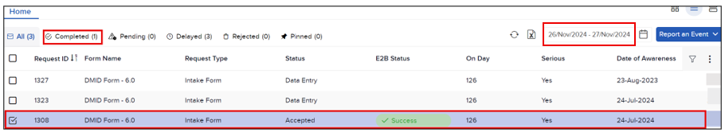

- Point to the right end of the selected row, and then click the View Request icon ().

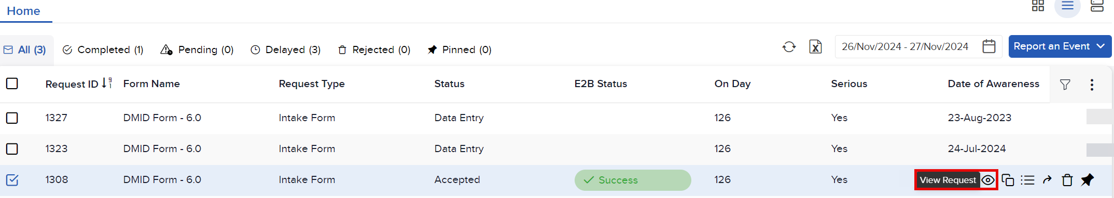
Note: The request is displayed in the Intake Form view but cannot be edited.

- Click the Attachments icon (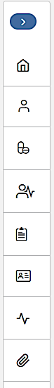) in the navigation pane to view the Attachments section.
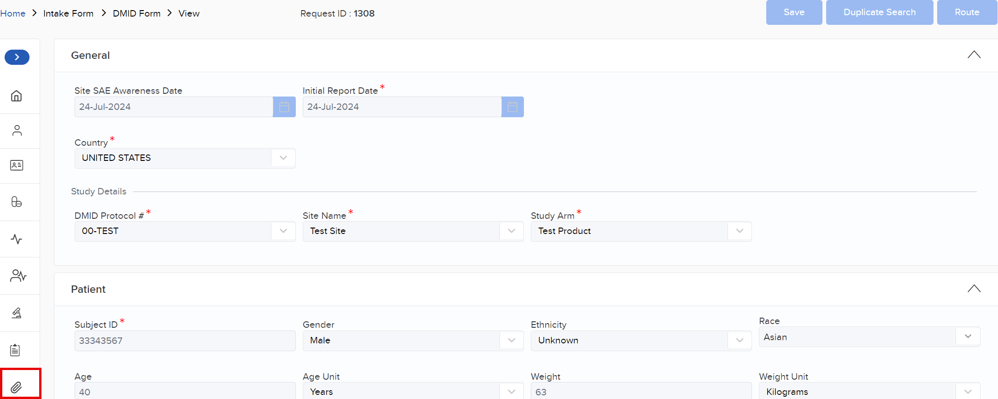

- Locate the desired attachment that begins with SNP-Request ID:

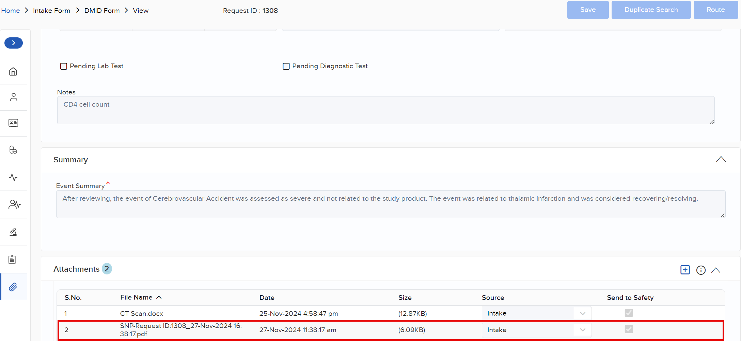

- Point to the right end of the attachment row, and then click the View icon ().

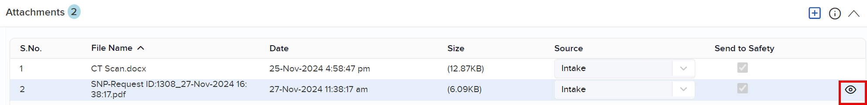

Note: A dual view displays the Intake view on the left, and the Print or Download view appears on the upper right.

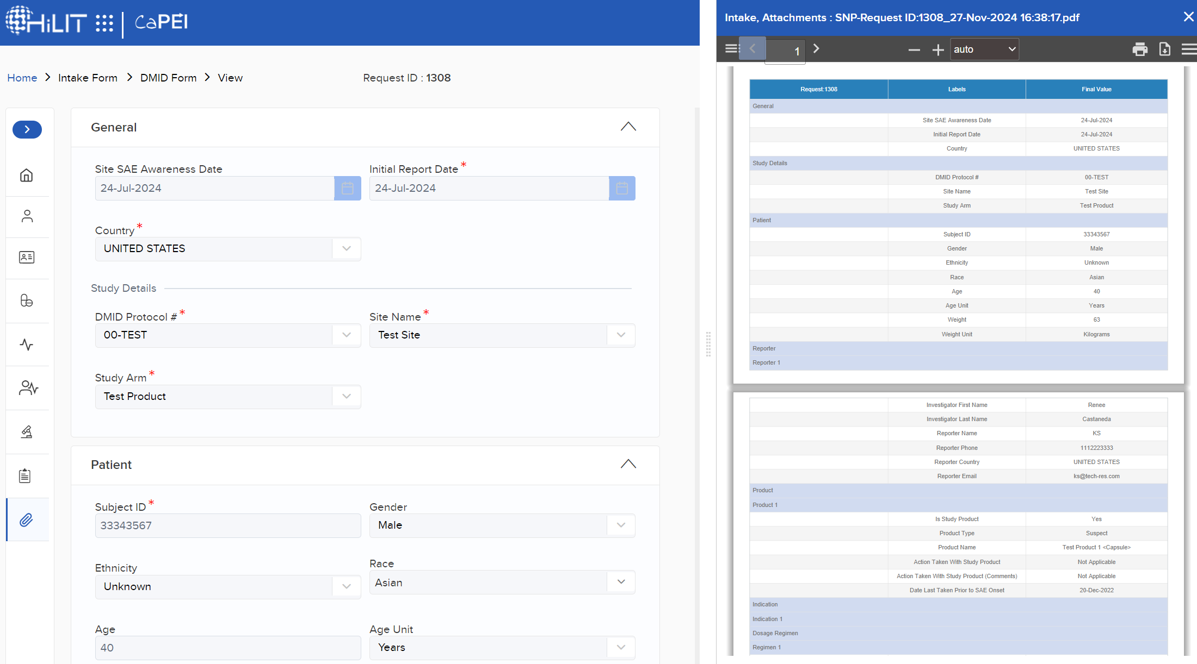or
- Click the Print icon () shown at the top of the Attachment view to print a hardcopy of the request.
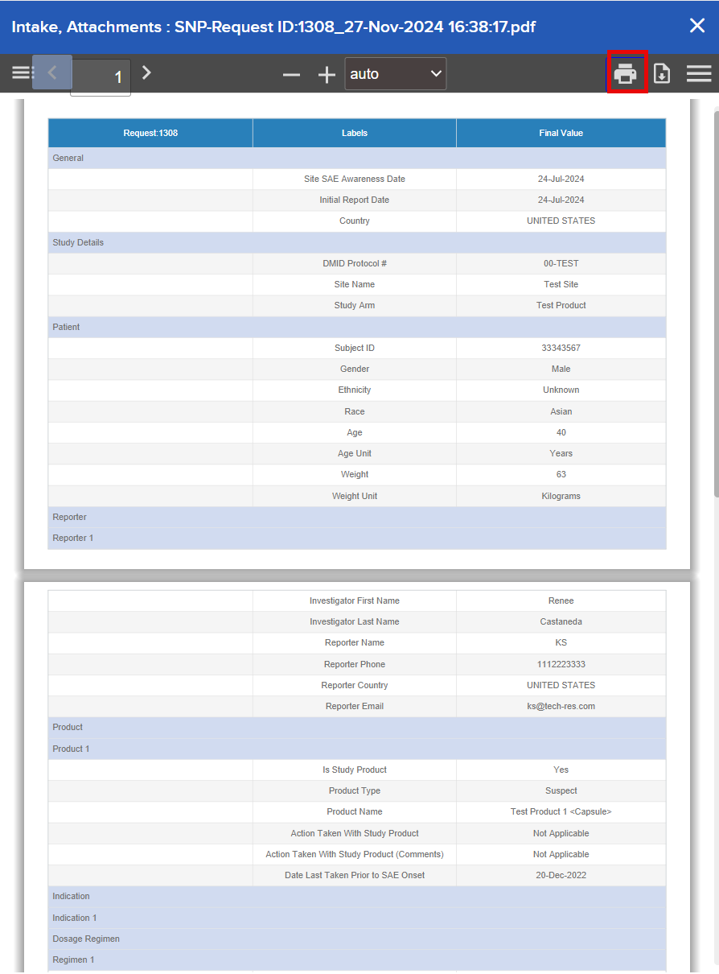

- Select an available printer to print the request.
Note: To save a PDF to your local drive, click the Download icon ().

