This quick start guide (QSG) describes how to enter safety information into the HiLIT electronic system.

Click on the links below to learn how to perform the following tasks:

- Logging into the DMID-CROMS HiLIT System
- Checking for Previously Submitted Cases
- Reporting an Event
- Entering Information
- Routing a Request
- Submitting a Request (PI)
- Contacting Staff for Assistance

Reminder: When providing copies of medical records, redact all personal identifiers (i.e.: names, addresses, birthdates, etc.) and label each record with the Protocol # and Participant ID #.

Logging into the DMID HiLIT System

- Open your web browser and navigate to https://www.dmidcroms.com. Please note that training is required for access to HiLIT. For training contact PVG@dmidcroms.com.

- On the login screen enter your username and password.

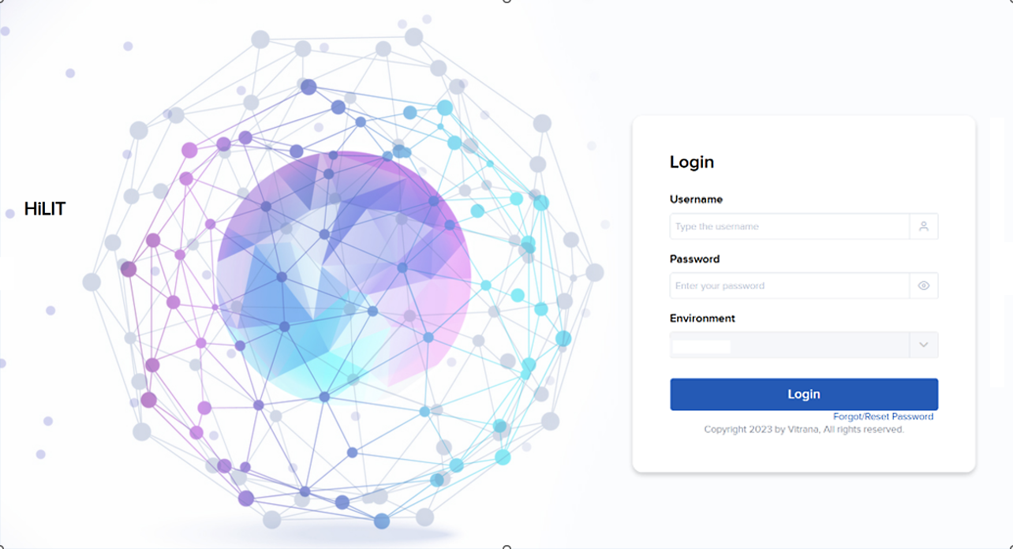

- HiLIT Login Credentials:
  - Username: [your site’s Microsoft Office 365 Credential]
  - Password: [your site’s Microsoft Office 365 Password]
  - Forgot/Reset Password. Click on this link to reset your password.

Checking for Previously Submitted Cases

Check for previously submitted cases:
- Before entering a new request, to determine whether a case was previously reported; or
- When following up on an existing case or previously submitted case.

- Click the Report an Event () down arrow.

- Select DMID Form to display a blank Intake Form > DMID Form.
- From the intake form, click the Duplicate Search (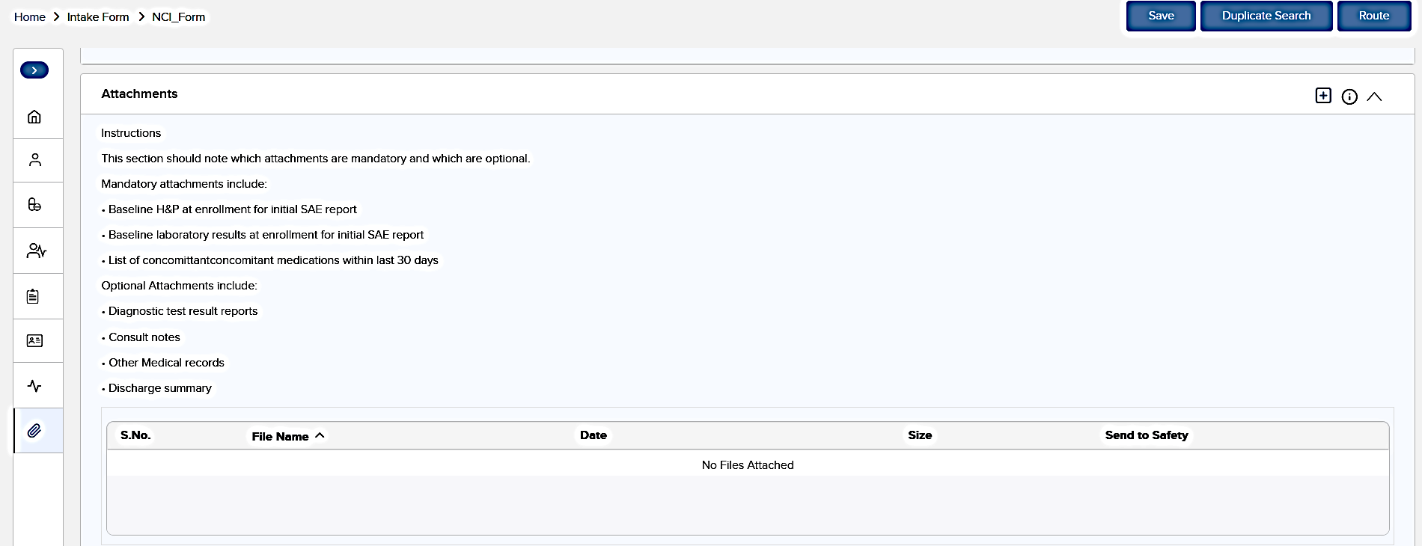) button.
- The Duplicate Search screen fields are displayed. Choose Select All or specific check boxes () to enter search criteria. Checked fields will be “required” data fields.

Note: The E/P option slider () searches for Exact or Partial matches for the Subject ID and DMID Protocol. In case of partial match, all the punctuation marks or special characters will be ignored.

- Once you have entered the search criteria, click the Search () button.

- Depending on the request status, select the desired action by clicking either:
Continue as Follow Up () or Continue as Initial ()

Only requests with a status Accepted have access to the Continue as Follow Up option. If selected, an intake form will display previously entered information in the database for the respective case, which can be updated as necessary.

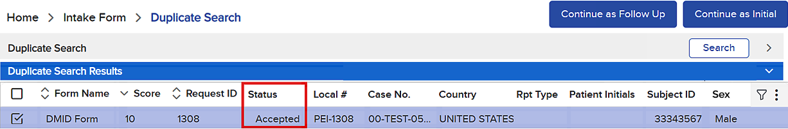

Only the Continue as Initial option is available for requests with status Data Entry, QC Pending, Pending Acceptance, or Rejected. Values entered for a duplicate search will be retained when continuing as an initial entry.

When submitting a new, different event for the same subject/participant, please proceed with an Initial request.

Reporting an Event

After login, the dashboard (or Home screen) is displayed. In HiLIT when you submit a safety event, they are called Requests.

Every new event for a subject/participant should be submitted as an initial report. Updates to initial reports are submitted as follow-up reports.

To create a new request for an initial report, click the Report an Event () down arrow. Select DMID Form. This initiates the process for entering information into the system.

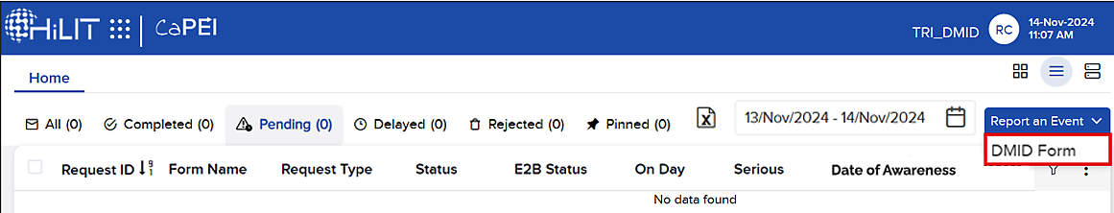

Entering Information

There are nine sections in the HiLIT system for entering safety information. It is mandatory to complete the required fields marked with the red asterisk (*). For each section, fill in the fields and provide complete and accurate information if available.

To navigate to a different section either scroll down the screen or click on an icon on the left side of the screen. Examples of completed screen shots are provided below for each section.

Information you entered in these sections will not save automatically. It can be saved at any time during data entry. Click the Save button (). The system will alert you of any missing mandatory fields but will not stop the save process. The system assigns and displays your Request ID number when the request has been successfully saved. For example, “Request ID: 1308 – Save Successful!”

General Section

Enter the Site SAE Awareness Date, Initial Report Date, Country, and the Study Details (DMID Protocol #, Site Name, Study Arm).
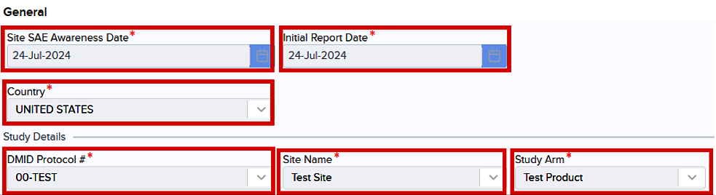

Patient (Participant/Subject) Section

Enter the Subject ID, Sex, Ethnicity, Race, Age, Age Unit, Weight, and Weight Unit.

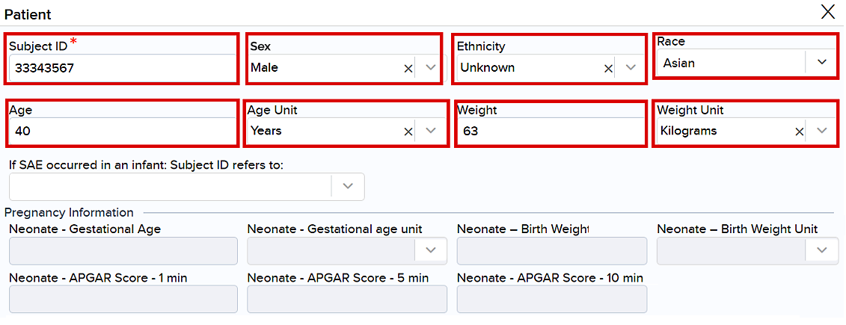

Reporter Section

This section is auto populated from the login credentials.

Note: Data Entry and Investigator information is also auto populated from the login credentials once the case is routed to Quality Control (QC).

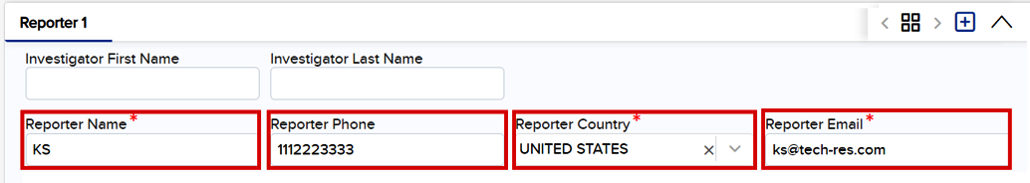

Product Section

When entering a study product, check the box next to Is Study Product and select the appropriate study product from the Product Name dropdown.

Next, select the most appropriate Action Taken With Study Product from the dropdown menu and enter the Date Last Taken Prior To SAE Onset.

Select the Product Type. Note: Suspect displays as the default for Product Type.

When entering a Treatment Administered or Concomitant Medication, leave Is Study Product unchecked, select the appropriate Product Type from the dropdown, and write in the name of the product under Product Name.

Enter the Dosage Regimen for each product and provide the requested dates.

Additional Study Product, Treatment and Concomitant product can be added by clicking the plus icon () in the top right corner of the product section.

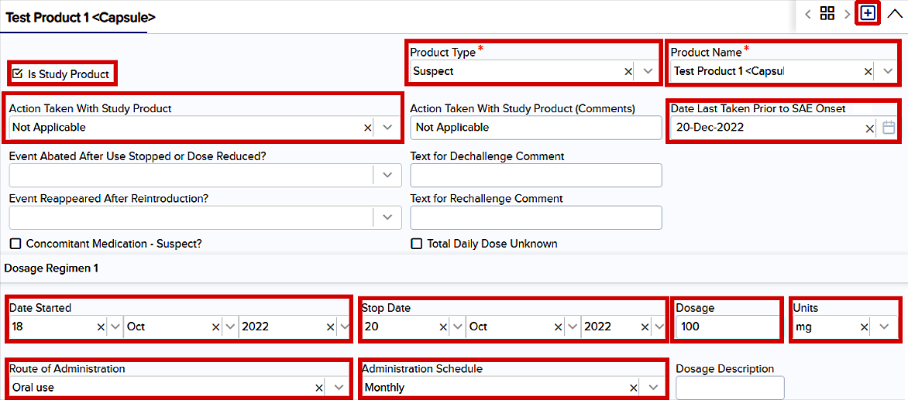

Test Attached Section

Check the box to indicate which tests are attached. The three options are Lab Results Attached, Diagnostic Results Attached, and No relevant laboratory tests. The respective tests can be attached in the Attaching Files Section.

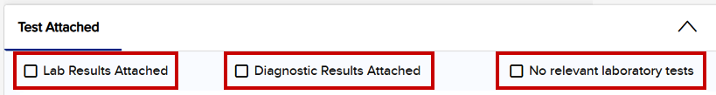

Events Section
Do not submit multiple events for the same subject. Please submit a new request for each event (see Reporting an Event and the Checking for Previously Submitted Cases sections).

Enter the SAE Term (Safety Event Term), Onset Date, Severity, Outcome, Recovered/Resolved Date (if resolved).

Check the Seriousness Criteria if the event meets serious criteria per protocol.

Enter Death Information (for fatal events).

Check any Other Requirement if the event meets other protocol-required reporting criteria.

Check an alternate etiology under If not related to Study Product, then Related to? if the event is not related to the study product. Write in the alternate etiology in the comment box.

Provide Causality Information for each study product.

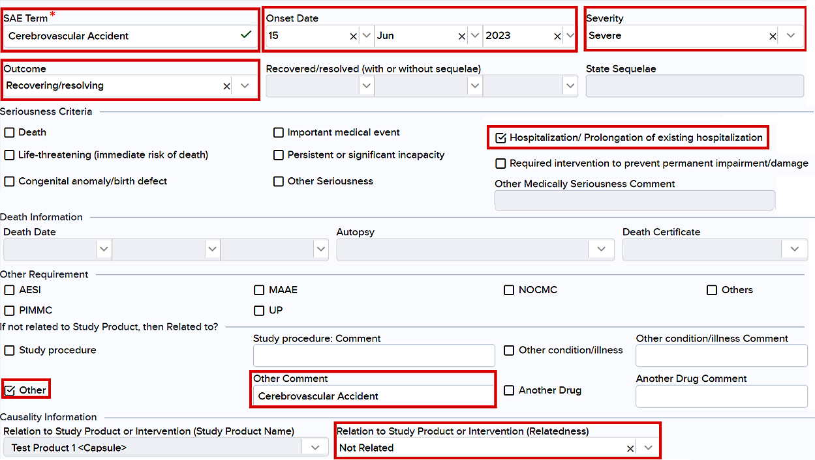

Lab Test Section

Enter the information requested for each test. Add any pertinent information in the Notes field.

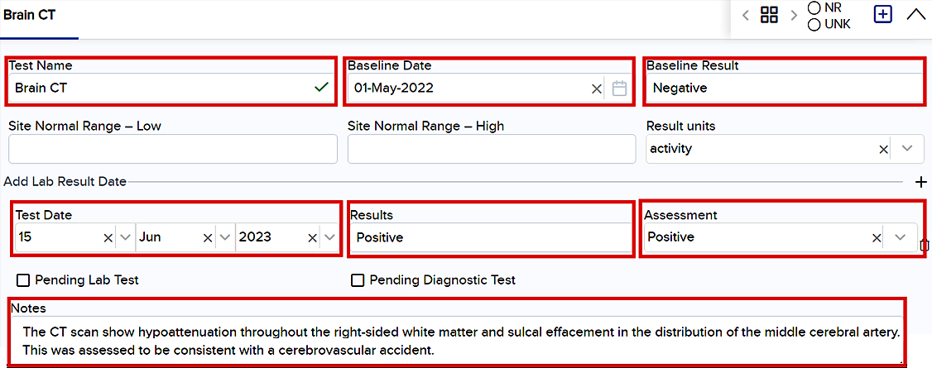

Summary Section

Enter a summary of the events or provide any additional information about the event in this section, for example:
- Chronological order of clinical course surrounding the event.
- Associated signs and symptoms.
- Participant's past relevant medical history, family history, social history, and allergies (for newborn and pregnant participant also include maternal history (obstetric and prenatal)).
- Reactogenicity records, current and past (FOR VACCINES ONLY). Provide local and systemic solicited adverse event records (i.e.: erythema, induration, fever, headache, etc.) for the participant.

Attachments Section

Click the plus icon () on the upper right corner to select the appropriate files to attach from your file folder. The number of attachments is displayed beside the word “Attachments” (e.g., Attachments 1). Attached documents are displayed at the bottom of the screen.

Note: When providing medical records, redact all personal identifiers and label with Protocol # and Participant ID #.
Check Send to Safety to submit to the safety database upon HiLIT case submission.

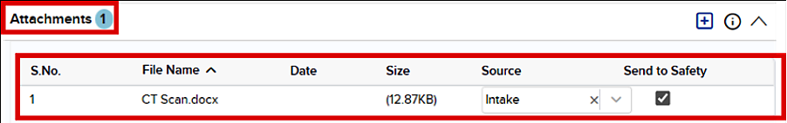

Routing a Request

Once all the required fields have been entered, the request can be routed to the Principal Investigator (PI) for review and approval. If the Reporter is also a PI, the Reporter can self-assign the request.

Note: The system will alert you of any missing mandatory and optional fields. The user will not be able to route the request for review if mandatory fields are missing. Optional fields will not restrict the user from routing the request.

- Click the Route button () to forward the request to a reviewer.

- Select a reviewer from the drop-down list or assign the request to yourself. Provide any comments for the reviewer, as applicable.

Note: An authorized Study Investigator or Sub-Investigator listed on Form 1572 must review all submitted safety events. If an authorized investigator is not available, users may submit safety events to avoid delays. DMID-CROMS PVG will query for an authorized user to review and approve the request.

- Click Proceed () to complete the routing. The system displays your Request ID number and a message that the request has been submitted successfully. You can keep the Request ID number to do a search for the report.

- Click OK (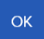) to complete the routing. The request should appear on the Pending tab of the dashboard/Home screen.

Note: Make sure to select the correct date range to view the desired requests.

Submitting a Request (PI)

After the PI reviews a request and determines the content is valid, the PI can submit the request to the safety database.

- From the dashboard Pending tab, click the Review icon () of the case with status QC Pending.

- Click the down arrow () to expand the desired section(s) in the Case to review and edit as needed.

Note: A Case Details summary screen gives the PI access to all the data fields entered for the case.

- If any edits were made, click the Save button () to update the request.

- Click the Route button ().
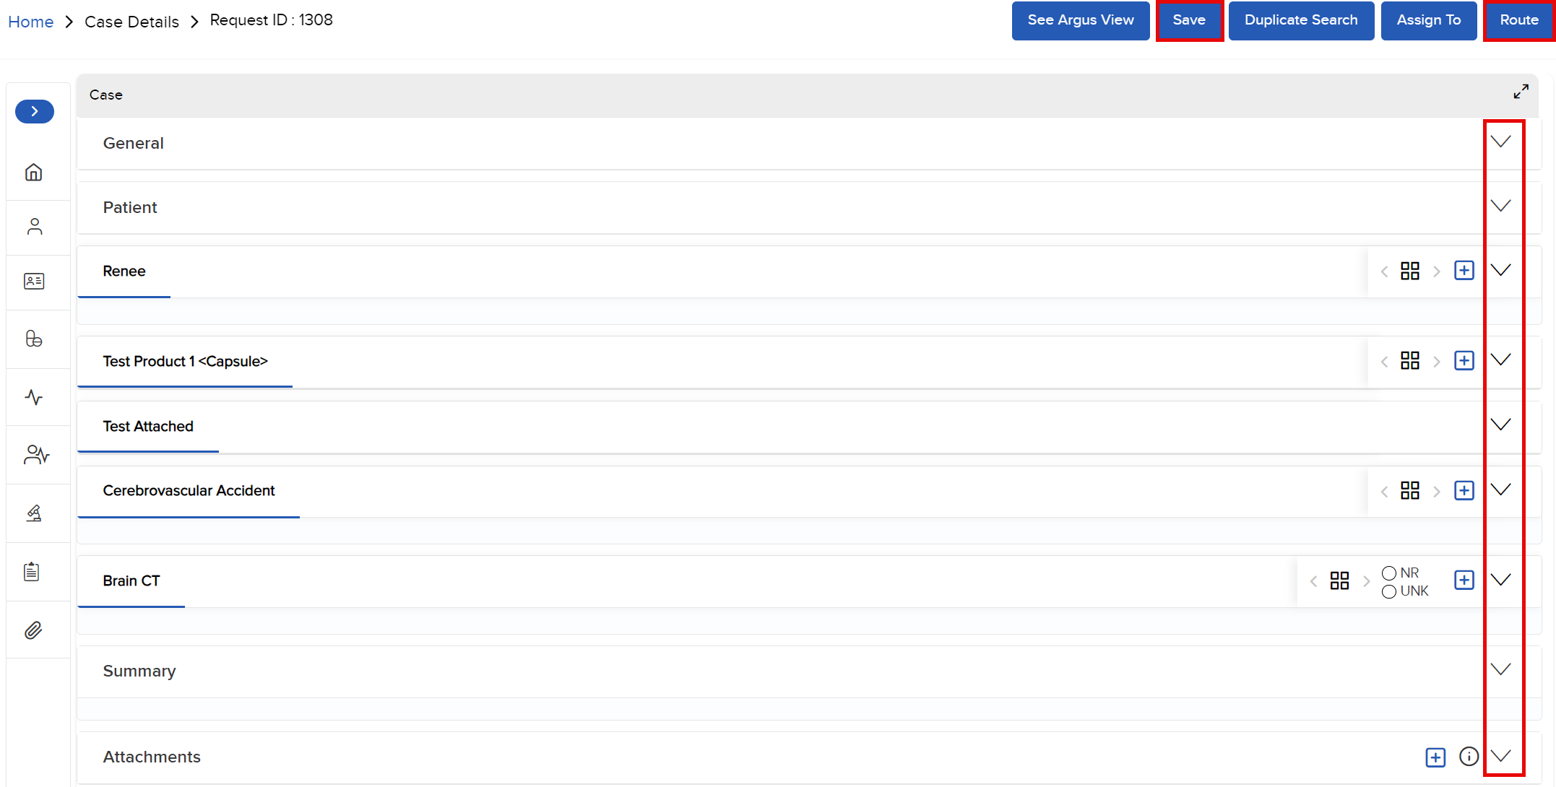

- Click Submit from the drop menu.

- Enter any appropriate comments and then click Proceed () to route to the next state.
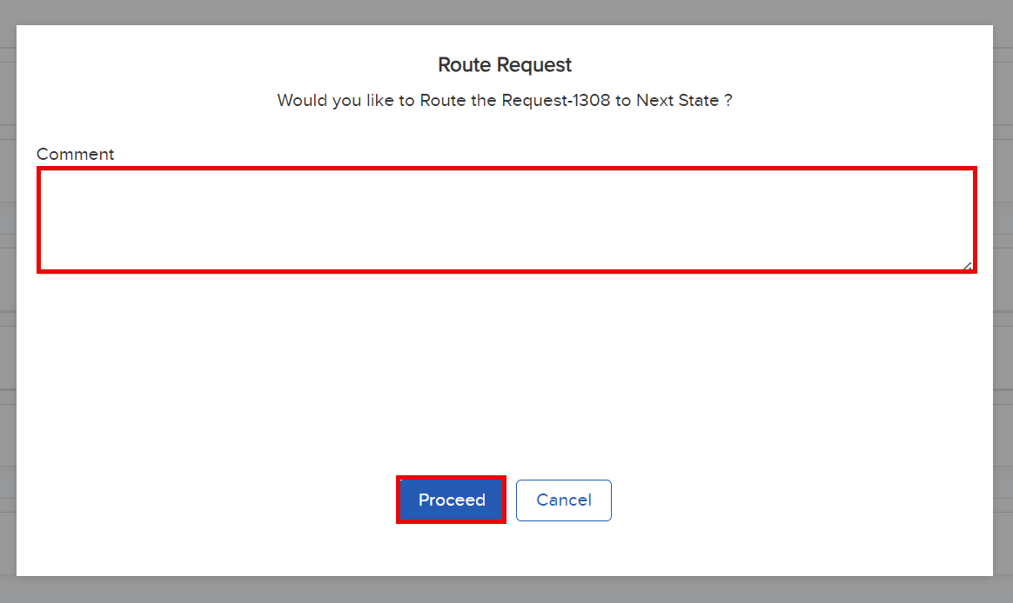

- Click OK () to complete the routing.
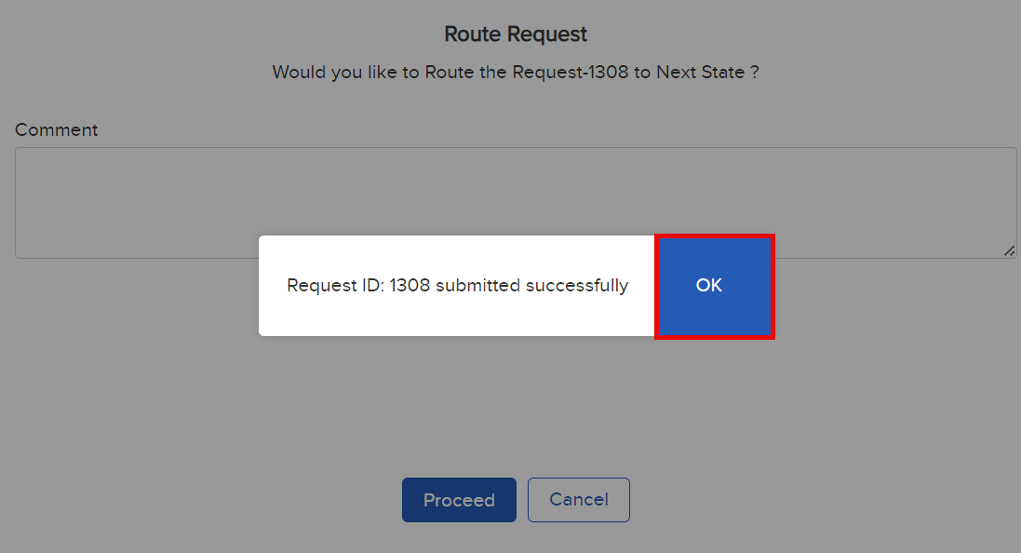

- Return to the dashboard (Home) and click the All tab.
Note: The submitted case appears with the status Pending Acceptance.

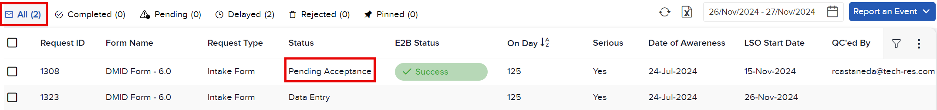

Note: Only the PI will receive email notifications when the status of a report changes. PIs will be recipients of automated notifications when a case is ready for their review, has been reviewed, has been submitted to DMID-CROMS PVG or transmission to DMID-CROMS PVG has failed.

Contacting Staff for Assistance

- For HiLIT technical questions contact: ITsupport@dmidcroms.com.

- For all other questions related to the report submission process contact: PVG@dmidcroms.com.

